 ** **

**Football Should be Fun!**

**RAMSBURY FOOTBALL CLUB NEWSLETTER**

**JANUARY 2024**

**Over 135 Years of Football in the Community**

Established 1887

**Dear Parents, Guardians and all involved with Ramsbury Football Club,**

2023 was yet another challenging year for everyone within and without our community. Despite all the difficulties faced, Ramsbury FC has continued to thrive, improve and cement our reputation as a fantastic grass roots football club. We now have 12 youth teams playing in the North Wilts Youth Football League; a competitive men’s team and a fantastic 36 strong Under 6s Development Squad. Ramsbury FC has never been so strong and the reason it is so successful is down to our fantastic sponsorship by Ergo FM, the selfless volunteering and commitment of parents and guardians and especially team coaches, team secretaries, the Club Committee and the Clubhouse Café Crew. .

Our superb sense of community is at the forefront of all we do and which reflects our identity, club ethos and the sense of purpose and fairness within all our teams, win or lose. It is fantastic to see and everyone involved with Ramsbury FC should be immensely proud of our Football Club, the facilities we have, the wonderful volunteer coaches we have and, importantly, the excellent reputation we deservedly have across our county and beyond. It is a Club to be proud of and everyone within Ramsbury FC does their part to make our small grass roots football club the envy of many other bigger clubs who we compete against. **Ramsbury FC Secretary.**

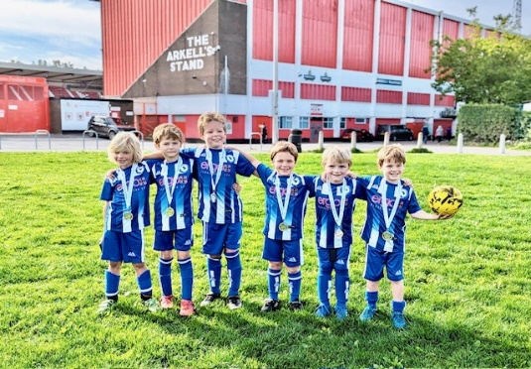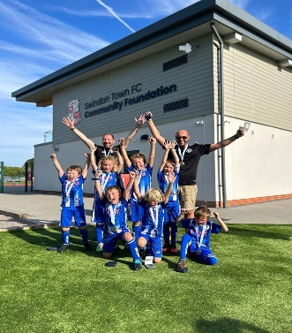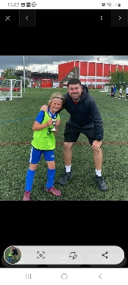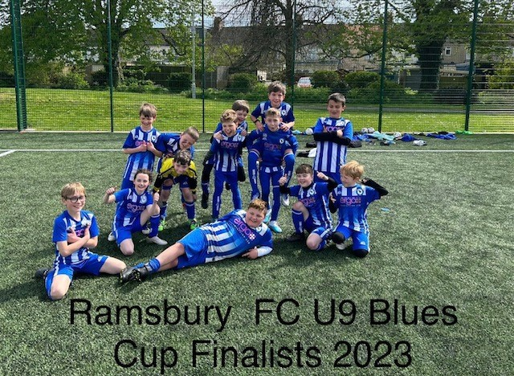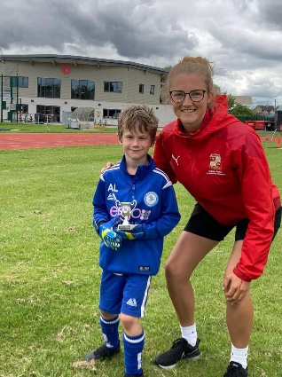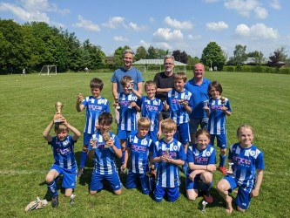

**RAMSBURY FC CLUBHOUSE CAFÉ**

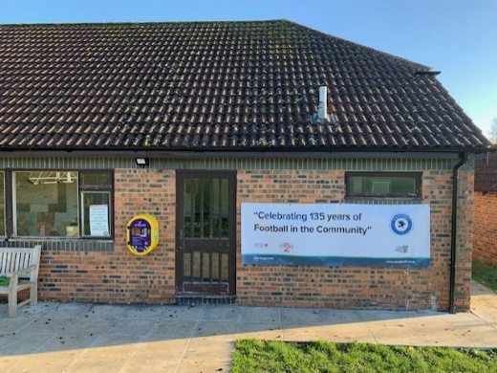 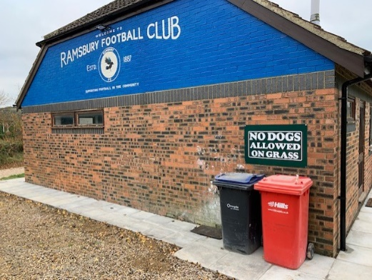 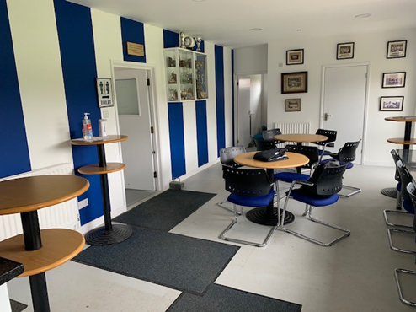Ramsbury FC, in partnership with our club sponsor Ergo FM, have provided a clubhouse to be really proud of and which continues to be the envy of many other (bigger) clubs! There are still things to do and improve and this year the club will replace the home changing room windows. Thereafter, we will look to replace all the other aging windows and doors and refresh the club mural on the wall close to the car park.

The Clubhouse Café continues to be a huge success and a great revenue stream. It will, however, only continue to be so with more volunteers. We currently have a small but very social ‘Clubhouse Café Crew’ that volunteer their time on a Saturday or Sunday morning selling sweets, making teas and coffees and making our very popular bacon butties**. Please do come and join them!**

If you can spare a Saturday or Sunday morning once a month then please contact Jon Symon or Fi Cresswell to volunteer for the Clubhouse Crew Rota. We will show you the ropes and then you will get to meet lots of other parents and children within your community as well as all our visitors. You are rewarded with a mug of tea or coffee and a bacon butty and being part of a great team!

**CONTACT the following to help out in the Ramsbury FC Cafe:**

**Fi Cresswell @ FionaMorley@sky.com or Jon Symon @ jonathansymon@hotmail.com**

**Come and join the Clubhouse Crew and help your Club and your youth football team! Also, a big shout out to Bee Curtis who keeps our club so clean and tidy and who does such an amazing job!**

**Our New Dug Outs Look Amazing!**

Our club sponsors Ergo FM in conjunction with Ramsbury FC and the Ramsbury Recreation Ground Committee built our fabulous new dug outs. We think they are great and our U6 Development Squad absolutely love them…especially when it is raining!!!! George Blanchard our DofE assistant coach and U14s player with the U6s

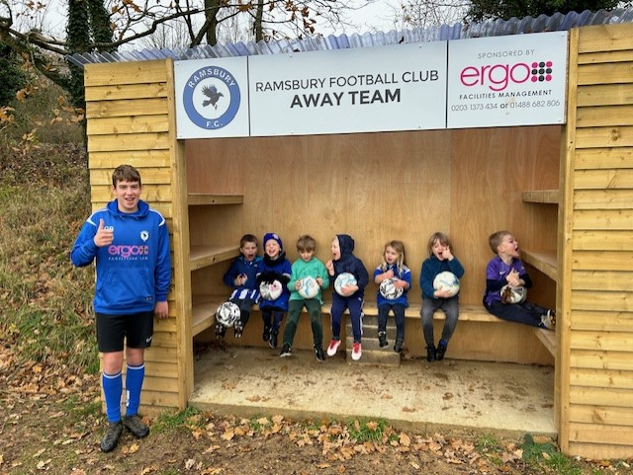

**2022-2023 Ramsbury FC End of Season Awards and Oli Kimber Cup Winner!**

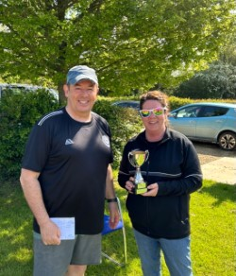 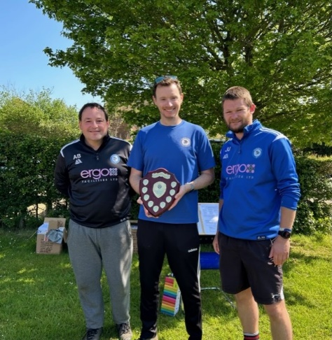 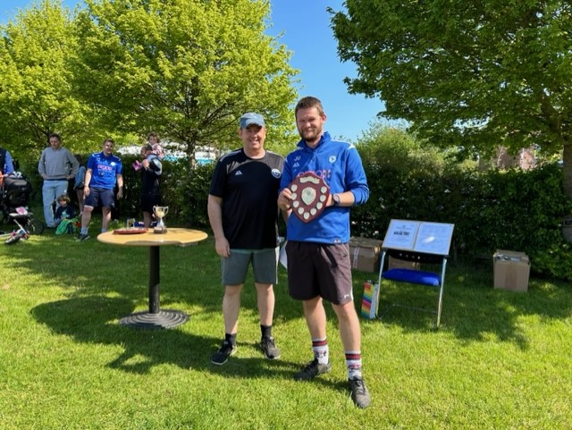

Ramsbury FC hold their end of season awards with a festival of football in June after the season has ended in early May and last year was one of the best yet! There was awesome weather, a superb BBQ and bar and, of course, lots of medals, cups and football. It was a great day and very well attended and a huge thank you goes to all those who helped make it such a special occasion.

**Club Awards went to the following:**

**Team of the Year – Ramsbury FC U8s (now the U9s)**

**Coaches of the Year – Rich Gillard & Adam Blanchard Ramsbury FC U14s**

**Oli Kimber Award for outstanding contribution to the Club –**

**Fi Cresswell – U9s / U10s**

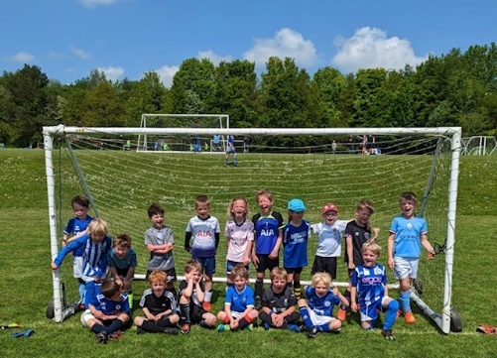 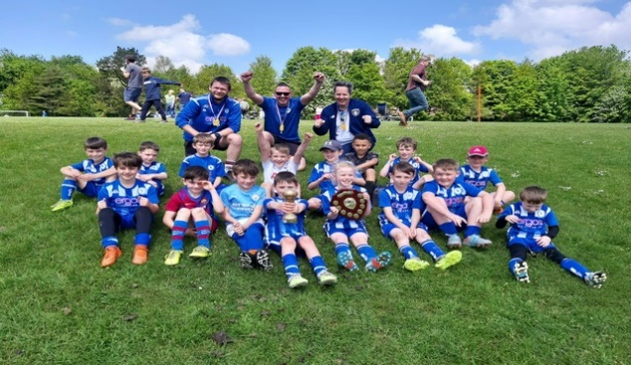 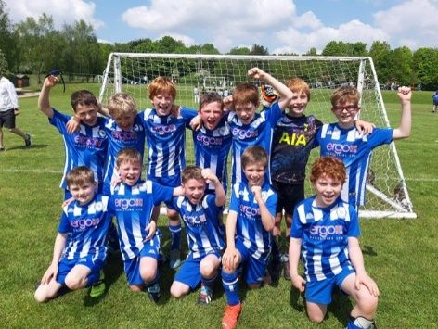

 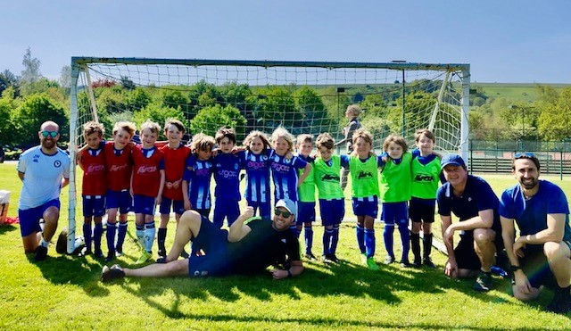

**Some of our Brilliant Volunteer Coaches**

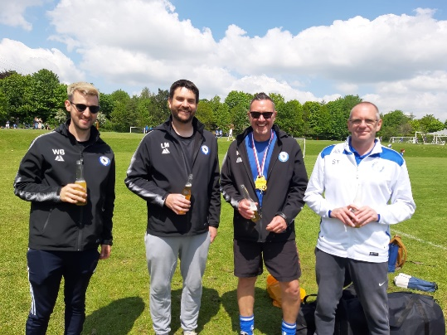 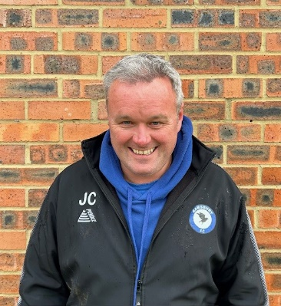 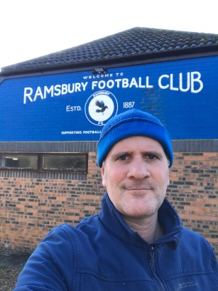 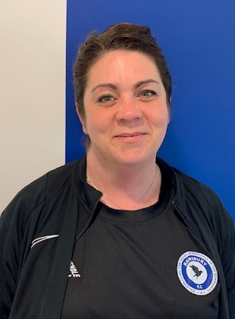

 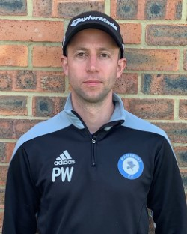 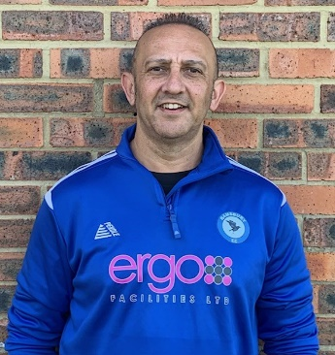 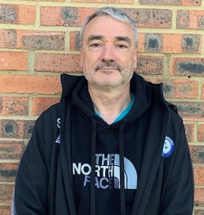 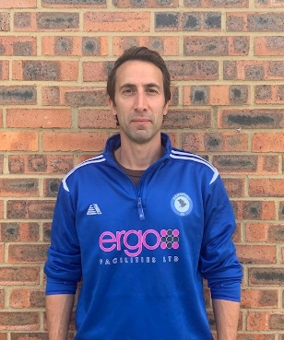

Ramsbury FC has 42 coaches and 8 Team Secretaries. All our coaches are fully qualified and are unpaid volunteers. They along with our growing number of team secretaries are the backbone of Ramsbury FC and without them we could not be the success we are. Our current team secretaries are:

* **U7s – Vicki Gray**
* **U8s – Georgie Littlewood** (replaced Chloe Martin)
* **U9s – Fi Morley**
* **U10s – Fi Morley and Shelly Baverstock-Seaman**
* **U11s – Glen Aylett and Mark Bevan**
* **U12s – Bryony Beck**

Ramsbury FC aspires to have a Team Secretary with every youth team to ease the administrative pressure on team coaches and this has been a huge success! So do make sure you know who your coaches and team secretaries are and please help them if you can.

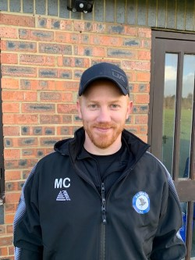 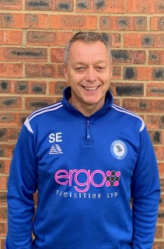 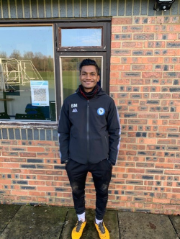   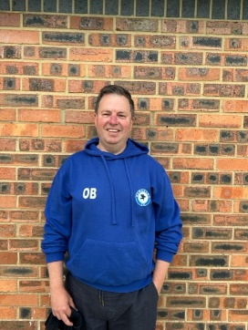

**Ramsbury FC Senior Team for 2023-2024 Season**

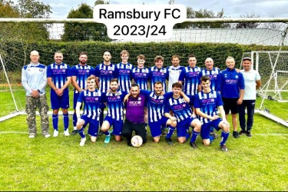

The senior squad is managed by Sean Eviil and play on Saturdays at 2pm and train Tuesday evenings 6.30pm to 8pm. The team play in the Swindon District League Div 1 and are always looking for players to join the squad.

If you are interested in joining the squad then contact [seanevill1962@gmail.com](mailto:seanevill1962@gmail.com)

**Christmas Drinks and a Curry for Ramsbury FC Volunteers - 2023**

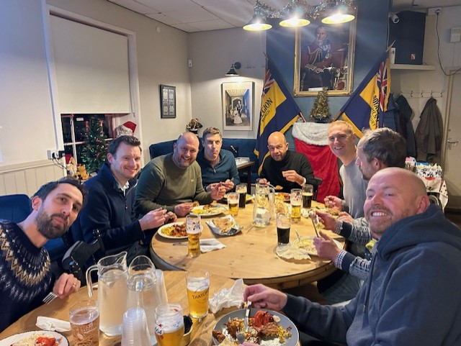

Ramsbury FC Coaches, helpers and committee members enjoyed another great night out in the Ramsbury Royal British Legion (RBL) on Wed 6th December. The function was arranged to thank all volunteer coaches and team secretaries for their commitment and support throughout the year.

The curry was provided by [Ruchi Indian Restaurant](https://ruchiindianrestaurant-sn1.co.uk/) in Old Town Swindon and once again was delivered by Bash Miah, the U11 Whites Coach, from his family’s restaurant. The food was simply outstanding and was ranged to suit all tastes from mild curries for the wusses to medium hot to spicily deranged for the hard core; and it was all washed down with plenty of drinks courtesy of Ramsbury FC. A huge thanks to Marion and all at the RBL who hosted our event brilliantly.

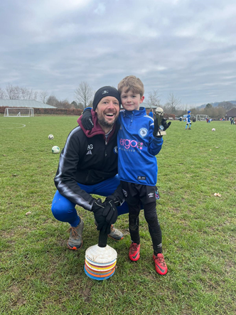**Best Dressed in Wiltshire - Ramsbury FC Online Shop**

All Ramsbury FC players and coaches continue to look fabulous in their distinctive Ramsbury FC / Ergo FM branded strips, tracksuit tops, beanies and hoodies. There is so much more now on offer in our online shop so go and have a browse.

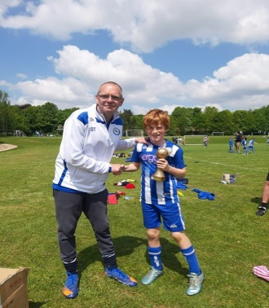The Ramsbury FC online shop is accessed via the Ramsbury FC web site [www.ramsburyfc.co.uk](http://www.ramsburyfc.co.uk) or via our partners Pendle Sportswear: [Products for Ramsbury FC (pendlesportswear.co.uk)](https://ramsbury-fc.pendlesportswear.co.uk/replica-products/football-training-wear/)

**Ramsbury FC win Wiltshire FA Wiltshire Sustainable Club of the Year - 2023**

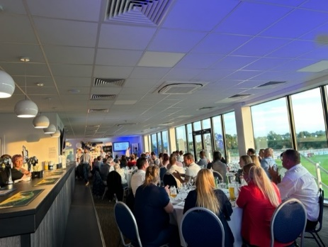 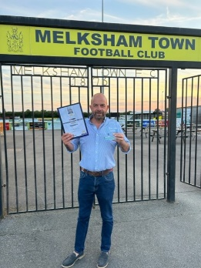 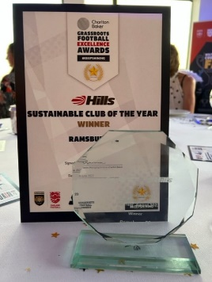 Great recognition!!!!

**More photos of Ramsbury FC Players, Coaches and Parents!**

 